Type of Components:

* Stateful:
  + When we are managing state in them and updating it by setState()
  + From React 16.8.0 we can also use Functional Components as stateful with useState() hook
* Stateless:
  + Component which doesn’t have state
  + Typically, we use Functional Components here
  + This are presentation type used to show data in UI

Life Cycle Hooks:

Pending

How React Updates The DOM:

* The render() not immediately renders content to Real DOM
* It is just a suggestion what HTML should look like
* It compares “Old V DOM” & “Re-rendered V DOM”
* V DOM is a DOM representation in JavaScript
* React maintains two copies of DOM (Old V DOM & New V DOM)

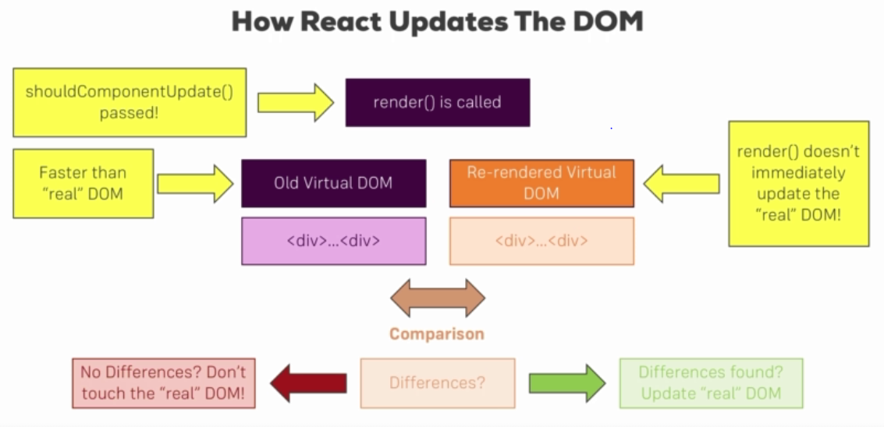

Higher Order Components (HOC):

* A higher-order component is a function that takes a component and returns a new component
* Whereas a component transforms props into UI, a higher-order component transforms a component into another component.
* **LEARN AGAIN WITH EXAMPLES**